

Personal Air Sampling Pump for Low Flow Applications
  - HB4089-03
  - November 2024

Contents
Safety and Warnings 5
Disposal 6
Disclaimer 7
Introduction 8
Controls and Fittings 9
Controls and Menu Structure 9
Tube Connections 10
Sampling Inlet Connection 10
Gas Bag Outlet Connection 10
Operation 11
Turn the Pump On/Off 11
Charge the Pump Battery 11
Setup before Starting a Run 13
Set the Flow Rate 13
Calibrate the Pump 13
Calibrate the Pump using Casella’s Flow Detective 14
Start/Stop a Sampling Run 14
Lock and Unlock the Pump 15
Partial Lock 15
Full Lock 15
Motion Sensing 16
Timer Programmes (Pro Models Only) 16
Timed Run 16
Run Sequence 16
TWA Run 17
Flow Mode 17
Gas Sample Collection 19
Settings 20
Language 20
Temperature Units 20
Pressure Units 20
Time and Date 20
Screen Contrast 21
Screen Timeout 21
Activity 21
Screen Rotation 21
Bluetooth (Pro model only) 21
Block Retry 21
Auto – Lock 22
Auto – Run 22
Pump Information 22
Diagnostics 22
Warning and Error Messages 22
Warnings 22
Errors 22
LED Indicators 23
Airwave Software for Mobile Devices 24
Bluetooth Connection and Security 24
Dashboard View 24
Control Panel 25
Menu Options 26
Send Results via eMail 26
Copy to Clipboard 26
Settings 26
About 27
Computer Download Utility 28
Install the Utility 28
Download Data from the Pump 28
Technical Specifications 30
Battery Performance Table 31
Declarations 32
Frequently Asked Questions 34
What is the difference between the Standard and Pro models? 34
I would like to upgrade models – is this possible? 35
What program options are there for the VAPex? 35
Is there an intrinsically safe version? 35
What is the recommended service interval for the VAPex? 35
How do I know what sorbent tubes and accessories I need for my application? 35
Why include a motion sensor? 36
Is wearer acceptance a problem then? 36
What is the battery life and charge time and what’s the benefit? 36
What is the flow control and why is that so important? 36
What is back pressure? 36
Servicing, Maintenance and Support 37
Servicing 37
Maintenance 37
Replacing the inlet filter 37
Support 38
Part numbers and accessories 38

Safety and Warnings
The VAPex does not present a safety risk when you use it as instructed in this User Manual. However, it is possible that the environment where you use the instrument may present a safety risk. For this reason, always follow correct, safe working practices.

 | WARNING  Although the VAPex is designed to be intrinsically safe (IS), you must comply with these instructions relating to intrinsic safety:  Instructions specific to hazardous area installations (reference European ATEX Directive (2014/34/EU, Annex II, 1.0.6.) and the following Intrinsic Safety Standards:-  IEC60079-0:2017 IEC60079-11:2011  The following instructions apply to equipment covered by certificate number: CML 19ATEX2328, IECEx CML 19.0100 for the VAPex series.  The following warnings should be observed for intrinsically safe versions of the VAPex Pump:-  - The VAPex Must only be charged using Docking Station, Casella part number 214020B or 214024C connected to a PELV/ SELV power adapter that meets the requirements for the rated Um (i.e. Casella part number PC18 or PC28).  - DO NOT use the battery charger in a hazardous area.  - DO NOT attempt to download data via USB in a hazardous area.  - DO NOT use the equipment if the outer case of the instrument is cracked as this invalidates the intrinsically safe certification.  - DO NOT service while in a hazardous area.  - The equipment is certified only for use in ambient temperatures in the range 0ºC to 45ºC and MUST NOT be used outside this range.  - The user MUST ENSURE that the I.S. rating of the pump to be used is suitable for the I.S. rating of the intended hazardous area.

CAUTION
The VAPex air sampling pumps are designed to be robust, however please use the pump as follows:
Do not drop the pump or subject it to mechanical shock.
Avoid letting the pump suck in water, solid materials or highly saturated or corrosive gases as this may cause damage and will invalidate the warranty.
The VAPex pump contains no user serviceable parts. If a fault is suspected, return the pump to Casella or a Casella approved service centre.

CAUTION
If the equipment is likely to come into contact with aggressive substances, take precautions to prevent the instrument from being adversely affected, so that the type of protection is not compromised (Aggressive substances such as solvents may affect polymeric materials.) Suitable precautions include, regular checks as part of routine inspections and establishing from the material’s data sheet that the pump is resistant to specific chemicals.

 | CAUTION  Repair of this equipment shall only be carried out by the manufacturer or an authorised representative in accordance with the applicable code of practice.  CAUTION  When Bluetooth® is enabled, care must be taken to avoid interference with sensitive equipment such as in medical, aviation or safety critical environments.

Disposal
 | WEEE Notice  At the end of the instrument’s life please do not throw away with the unsorted municipal waste. Please recycle with a registered WEEE handler.

Disclaimer

Do not use the VAPex until you have thoroughly read this manual or have been instructed by a Casella engineer.

At the time of writing, this manual was up to date but due to continual improvements the final operating procedures may differ slightly from those in the manual. If there are any questions please contact Casella for clarification.

Casella makes continual advancements in its products and services. We therefore reserve the right to make changes and improvements to any information contained within this manual.

Whilst every care is taken to ensure that the information in this manual is correct, Casella will assume no responsibility for loss, damage or injury caused by any errors in, or omissions from, the information given.

Introduction
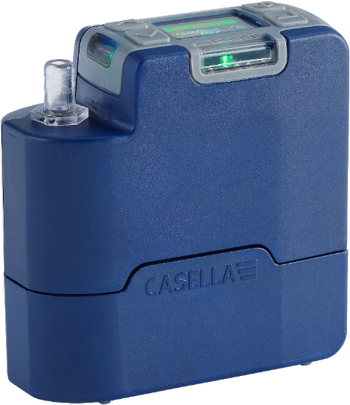
The VAPex is the latest generation of personal sampling pump for gases and vapours, which can now be monitored from your mobile phone or tablet without disturbing the wearer using the Airwave App and Bluetooth® 4.0 connectivity (Pro model). On models without remote connectivity, all the running parameters are clearly displayed on the pump LED screen.

Motion sensing allows you to confirm that the pump is being worn, and the slim ergonomic design provides a high degree of wearer acceptance. To provide greater protection against dust and water ingress the pump is IP65 rated and its smooth finish makes it easier to decontaminate.

The VAPex is designed for particularly low flow sampling applications with a range of 20 to 500 ml/min and an impressive back pressure capability, which ensures it operates reliably with a wide range of sorbent tube media. Inlet pressure is continually sensed to establish sorbent tube loading and aid diagnostics. Gas and vapour collection is also possible using the gas bag outlet on the pump.

On a full battery charge the pump is designed to operate for up to four 8 hr shifts before it needs to be charged up. A gauge shows the battery charge level, and on the Pro model, the remaining run time.

The following table summarises the features and capabilities of the VAPex range of pumps.
 | VAPex | VAPex Pro
Intrinsically safe | ✔ | ✔
Motion sensor | ✔ | ✔
Constant pressure mode | ✔ | ✔
Bluetooth® |  | ✔
Remote Connectivity |  | ✔
Computer download |  | ✔
Run duration timer |  | ✔
Fully programmable timers |  | ✔
Flow and motion logging |  | ✔

Controls and Fittings
The VAPex has a limited number of easy to use controls.

Controls and Menu Structure
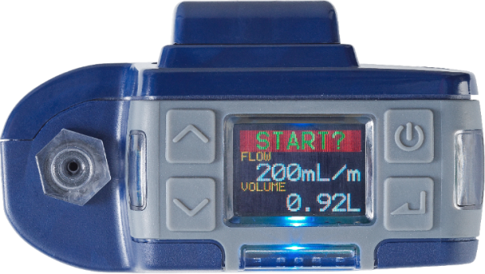
Inlet nozzle
Scroll up / increase
Scroll down / decrease
Status indicator
See LED Indicators on page 23
On / off / cancel
Start / stop / enter
Colour display
View all run parameters and menu items
Status indicator
See LED indicators
on page 23
Status indicator
See LED indicators
on page 23
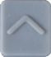   | The up / down arrows are used to scroll through menu and setting items and also to change values.
 | The On / Off button is used to turn the pump on and off, and to return to a previous screen.
 | The enter key is used to enter sub-menu items and to save changed values.
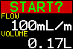 |  | This is one of three dashboard screens that cycle after you turn on the pump. The same information is also displayed when the pump is running (see Operation on page 11). To temporarily maintain a single screen as the visible screen, press and hold 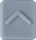.
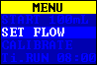 |  | This is the menu that you use on a regular basis to reset, set the flow and calibrate the pump between sample runs. It also gives you access to timer control (see Setup before Starting a Run on page 13 and Timer Programmes (Pro Models Only) on page 16).
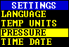 |  | The settings can be used to change the functionality of the pump or to access diagnostic information. You’ll probably only access the settings infrequently (see Settings on page 20).

Tube Connections

Sampling Inlet Connection
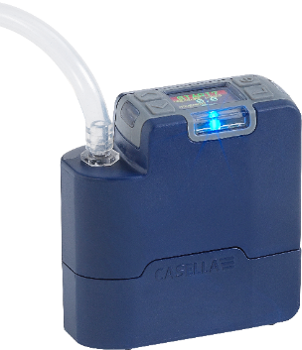
Connect the collection head tube to the inlet nozzle on the pump

Gas Bag Outlet Connection
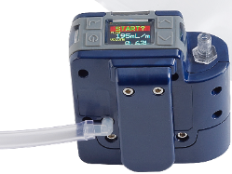
When using the pump to collect gas, connect the gas bag tube to the pump outlet using the supplied Luer fitting.
Note: The gas bag tube must have a nominal inside diameter of 5 mm.
To collect a gas sample see Gas Sample Collection on page 19.

Operation
This section describes how to use the pump to take gas samples using the minimum of settings. The VAPex has many other menu and settings options and these are described in later chapters.

Turn the Pump On/Off
To turn on the pump:
On the top of the pump, press .
The following sequence is displayed showing first the model variant and then the firmware version. However, the firmware version screen only comes up on VAPex Pro models.
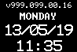
This is followed by the three alternating dashboard screens, showing data from the last run. Notice that the screen header is prompting you to start a sampling run.
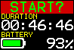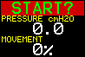
To turn off the pump:
On the top of the pump, press and hold until the countdown has finished and the screen goes blank.
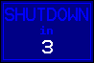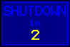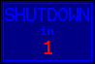
Note: You can’t turn off the pump during a sampling run or when a programme timer is set.

Charge the Pump Battery

Before using the pump, check the battery level icon or battery gauge to ensure there is enough charge for the intended sampling run. A good discipline is to place the pump on a charger at the end of the shift so that it is always fully charged at the start of the next shift. Remember, it takes approximately 6 hours to fully charge a pump battery.

To check the battery level:
- Turn on the pump as described above.
- Check the battery level, which will show either a percentage when the pump is not running or the number of hours remaining when the pump is running (except Standard VAPex which will show percentage).
- Turn off the pump.
The VAPex is supplied with either a single or five-way charger station and power supply. You cannot interchange the power supplies of the two chargers.
The chargers include a USB port for downloading data from the pump to a computer (see Computer Download Utility on page 28).
To charge the pump battery:
- Ensure that the pump is either off or on but not running.
Note: If you place the pump on the charging station while running, it will be powered by the charger and will continue sampling, however it will take longer to charge.
- Place the pump on a charging station in the orientation shown below with the belt clip towards the power supply connection end.
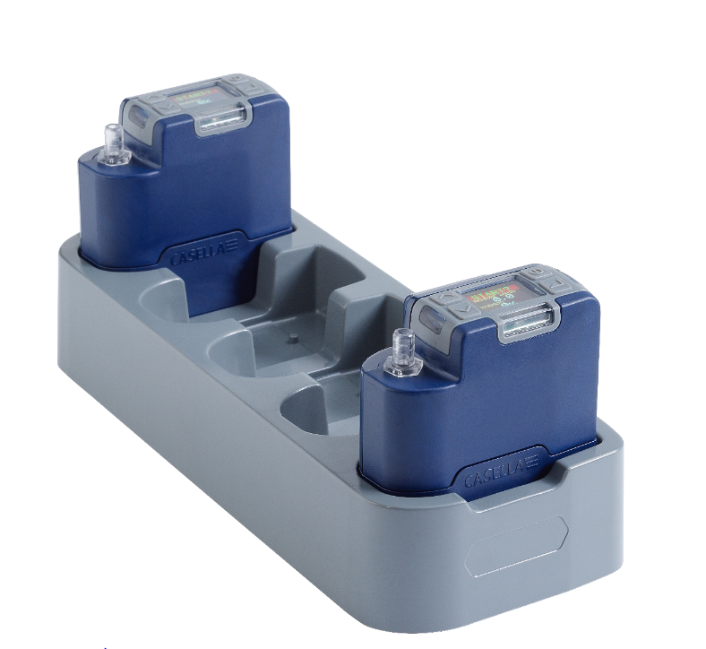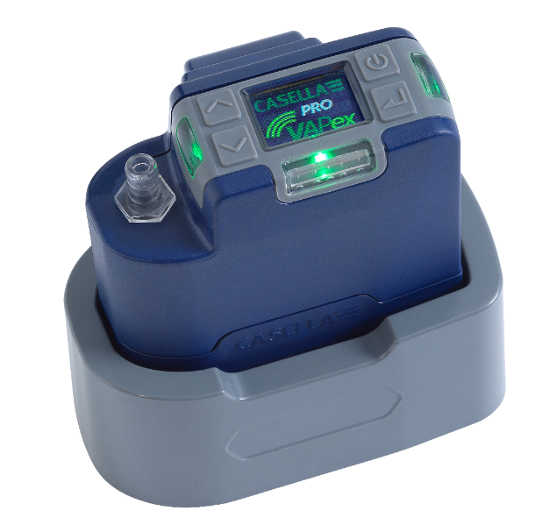
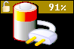
The LEDs on the top of the pump flash according to the amount of charge in the battery (see LED Indicators on page 23) and the charge state is displayed for a user defined period.
- To see the amount of charge at any time press .
Once fully charged the Green LED turns on for 10 minutes, after which time the pump turns off.

Setup before Starting a Run
Depending on your sampling requirements you may want to perform one or more of the following setup procedures before starting a sampling run.
To access the menu items described below:
Ensure the pump is turned on and then press  to display the menu.
Press or to highlight the menu item you want to alter, and then press .

Set the Flow Rate
- Navigate to SET FLOW, and then press .
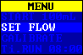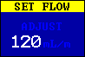
- Press or to change the flow rate, and then .

Calibrate the Pump
Always calibrate the pump at the sampling flow rate for greatest accuracy.
Note: If using a sorbent tube or if operating at a high flow rate, which results in a high back pressure, it may take the pump a little longer to stabilise when adjusting the calibrated value.

- Attach a sorbent tube or other flow-measuring device to the pump’s inlet nozzle. The flowmeter should be connected to the inlet of the tube.
- Navigate to CALIBRATE.
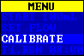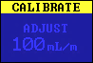
- Press to start the test.
- Press or to change the pump speed until the meter flow rate and the pump flow rate match.
- Press to stop and save the test.
Note: If you press during calibration it will cancel the process and will not save the calibrated value.

Calibrate the Pump using Casella’s Flow Detective

VAPex can also be calibrated wirelessly using Casella’s Airwave App and Casella’s Flow Detective (Flow meter). The Airwave App can connect to the Flow Detective and VAPex simultaneously. This will allow calibration of the pumps without having to access the menus on the pump at all, saving time in calibration.

Details of performing a closed-loop calibration using Flow Detective can be found in the handbook of the Flow Detective (HB4087) freely available to download from Casella’s website.

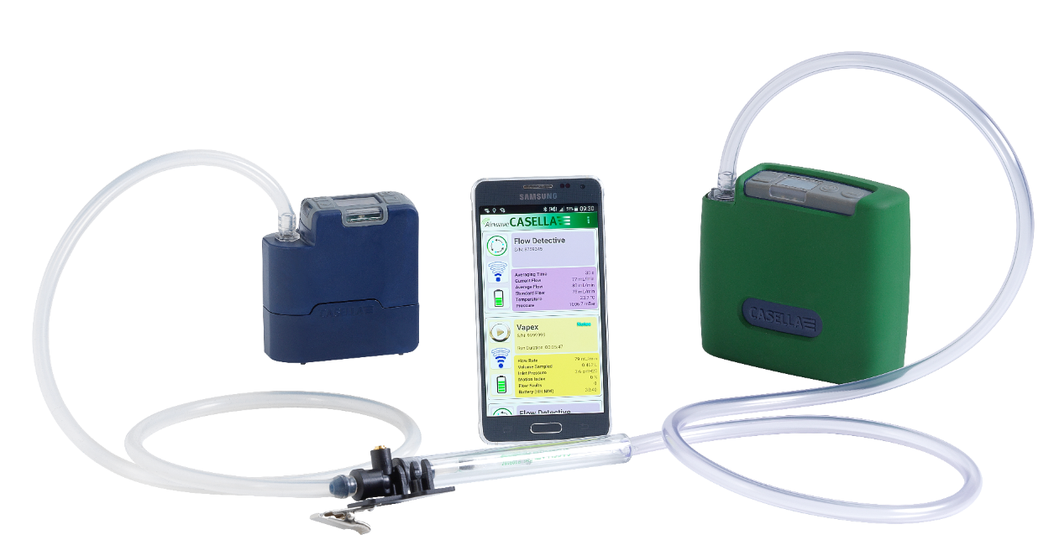
VAPex shown in closed-loop calibration

Start/Stop a Sampling Run
Ensure your pump is calibrated and set to the correct flow rate. If you want to start a timed sampling run see page 16.
To start a sampling run:
- Turn on the pump.
- Press and the following screen is displayed.

- Press or to select NEW RUN or RESUME.
Note: When you select NEW RUN the accumulated run time, motion index and volume data are reset to zero. The run is stored as a new measurement in the memory.
- Press for 3 seconds.
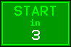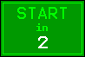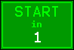
The following screens should be visible.
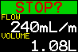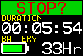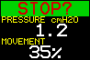
To stop or pause a sampling run:
- Press for 3 seconds.
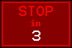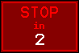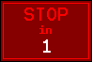
Note: You can resume a run after it has been stopped.

Lock and Unlock the Pump
The pump has two locking modes as described below.

Partial Lock
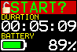
Partial Lock mode is denoted by a half open padlock icon and can be set in Run or Stop modes. While partially locked, the wearer may stop and start the sampling pump but has no access to the menu or other functions. To partially lock and unlock the pump:
- Press and hold , and then press 3 times within quick succession. The partial lock icon will be displayed.
Note: If you try to remove a partial lock when the pump is running you will need to apply the above procedure twice, which applies and then removes a full lock.

Full Lock
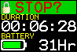
The full lock can only be set when the pump is running and is denoted by a closed padlock icon. While fully locked, the keypad is fully de-activated. The wearer cannot stop or disturb the pump by any key presses.
To fully lock the pump:
- Press and hold , and then press 6 times in quick succession. The full lock icon will be displayed.
To unlock the pump:
- Press and hold , and then press 3 times in quick succession.

Motion Sensing
The VAPex includes a motion sensor, which reports the amount of time the pump is moving as a percentage of the sample run time (shown as 35% in the example on the right). This ensures wearer compliance giving you confidence in the validity of the sample.
Note: The percentage value is only updated after a fixed time interval that you set in minutes. The available intervals are 1, 3, 5, 10 or 15 minutes (see Activity on page 21). If there is more than 50% user activity within any selected interval the pump will class this as full motion activity.

Timer Programmes (Pro Models Only)
The duration and programmed sequence timer functions are only available when ADV. MODE (Advanced Mode) has been enabled in the SETTINGS menu (see page 20).

Timed Run
Using this mode, you can run the pump for a set period, after which the pump will turn off automatically.
To start a timed run for a set period:
- Navigate to Ti.RUN 08:00, and then press .
Note: 08:00 in this example is the previously set time.
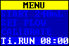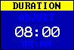
- Press or to set the time in hours and minutes.
- Press for 3 seconds to start the timed run.

Run Sequence
The RUN SEQUENCE timer allows up to nine ON and OFF events to be run in sequence. These may be used to define daily or weekly sampling sequences. For example, sampling may start in the morning then automatically pause for a worker’s lunch or rest breaks. A number in the corner of the screen identifies each sequence.
To set up a run sequence:
- Navigate to SEQUENCER, and then press .
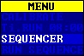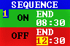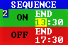
A sequence runs until an OFF period has been set to END. In the example above the pump runs in the morning and afternoon with a one hour stop during the wearer’s lunch.
- Press or to scroll to any of the settings and press to enter/save a setting.
To start the run sequence:
- Navigate to RUN SEQUENCE, and then press .
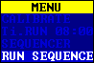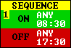
- Press for 3 seconds to start the run sequence.

TWA Run
In time weighted average (TWA) mode the pump samples for a proportion of the specified run time (called the exposure time). The pump calculates the required ON/OFF cycle to spread the total sample time evenly over the run time. The ON time is always 1 minute and the OFF time is varied according to the calculation. For example, with an exposure time of 2 hours and a total run time of 8 hours the pump turns on for 1 minute every 4 minutes.
To start a TWA sampling run:
- Navigate to TWA, and then press .
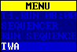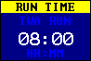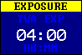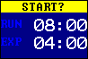
- Press or to set the run time in hours and minutes, and then press .
- Press or to set the exposure time in hours and minutes.
- Press for 3 seconds to start the pump immediately.

Flow Mode
Flow mode enables the pump to be operated as follows:
- Outlet flow is controlled – this is the normal setting for gas sampling in which the flow rate is controlled by varying the back pressure.
- Inlet pressure control (otherwise known as Constant Pressure Mode) – use this setting to set the inlet pressure to a fixed value. This would normally be used for sampling with multiple sorbent tubes (e.g. charcoal).
To set the flow mode:
- Navigate to FLOW MODE, and then press .
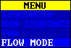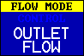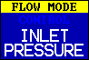
- Press or to select either OUTLET FLOW or INLET PRESSURE, and then press .
- If you selected INLET PRESSURE, the last action takes you to the SET PRESSURE menu option (which replaces the SET FLOW option). Press or to set the pressure, and then press .
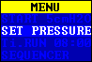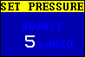

Gas Sample Collection
The pump has an outlet to which you can connect a gas sample bag. When operating in bag fill mode the pump runs until the back pressure reaches 15 mBar and therefore it automatically fills bags of any size.
To collect a gas sample:
- Connect the gas bag (see Gas Bag Outlet Connection on page 10).
- Navigate to SET FLOW, and then press .
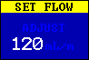
- Press and hold until BAG FILL is displayed.
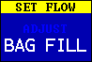
- Press to save the setting.

Settings
This section describes the settings you may wish, or need, to alter occasionally, and it describes how to access system information you may be asked for by a service technician.
To access the SETTINGS menu:
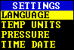
Press
With the Casella screen visible,
press and hold
+
Press or to scroll to any of the following settings.
Press to enter/save a setting or move between values, and press to go back.

Language
Supported languages include English, Spanish, Italian, German, French, Portuguese, Brazilian and Chinese. | 

Temperature Units
Select Centigrade or Fahrenheit. | 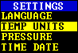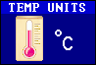

Pressure Units
Select cmH2O, kPa, “H2O or mBar. | 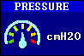

Time and Date
Set the date and time. Press enter to sequence through the numbers to be set. | 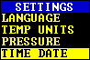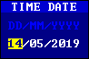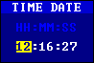

Screen Contrast
You may want to reduce the contrast for operation in low light conditions. | 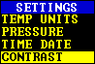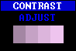

Screen Timeout
Use a screen timeout if you want to save power. Once the screen is off, press any key to turn it on again. | 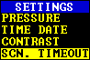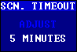

Activity
Set the averaging period of the motion sensor in minutes. | 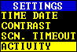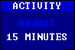

Screen Rotation
Allows the screen to rotate 180° when the pump is held horizontally and rotated. | 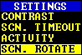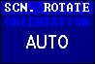

Bluetooth (Pro model only)
Enable or disable Bluetooth. You need to enable Bluetooth when using the Airwave app (see page 24). | 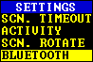

Block Retry
When the inlet is blocked for more than 20 seconds the pump stops sampling. After 1 minute the pump tries to resume sampling. | 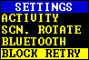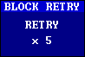
You can set the number of retries before the pump stops working.

Auto – Lock
Use this setting if you want a full lock (see page 15) to be applied automatically after you start the pump. | 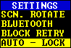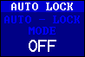

Auto – Run
When set to ON the pump runs automatically when it is placed on the charger. Use this mode when, for example, you want to run a static long-term sample in a non-hazardous area. | 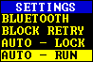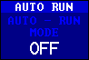

Pump Information
Use this setting to see the serial number and firmware version. A contact telephone number is also provided. | 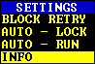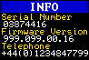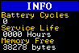

Diagnostics
This information is intended for routine maintenance and fault diagnosis. | 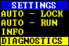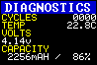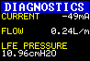

Warning and Error Messages

Warnings
When turning the pump on, if the battery level is below 10% a warning message will be displayed. The pump will then switch off. Recharge the pump as necessary.

Errors
If the pump cannot maintain the target flow rate within 5% for more than 20 seconds (due to a kinked tube or inlet blockage) then it will automatically stop sampling and show the Blocked Retry message. | 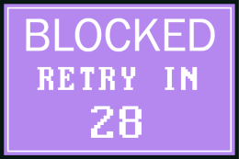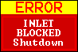
After one minute the pump will attempt to re-start. If the pump has not been able to re-start after the specified number of retry attempts, the pump will terminate the current sampling run and display an error message.

LED Indicators
The VAPex pump has three LEDs to indicate various operational states. These are positioned near the controls on the front (red/green/blue) and sides (red/green) of the pump.
VAPex status | LED colour | LED state
In run mode | Green | Front and side LEDs flash alternately
In standby mode | Blue | Flashes if Bluetooth is enabled
Inlet partially blocked | Red | All red LEDs – double flash
Inlet blocked | Red | All red LEDs on
Bluetooth advertising | Blue | Flashes
Bluetooth connected | Blue | On
Battery < 25% charged | Red | Front LED flashes
Battery < 50% charged | Green | Front LED flashes
Battery < 75% charged | Green | Side LEDs flash
Battery 75 to 99% charged | Green | Front and side LEDs flash
Battery fully charged | Green | On
Timer standby | Blue and red | Blue and side red LEDs flash
Start up | All LEDs | Light show
Shut down | All LEDs | Light show

Airwave Software for Mobile Devices

The Airwave software allows you to control and check the pump’s status and measurement progress without having to disturb the wearer who may be performing a critical task or is unavailable.
Note: Your mobile device must support Bluetooth®4.0 connectivity and must be running Android version 4.3 or higher. Check your device specifications if unsure.
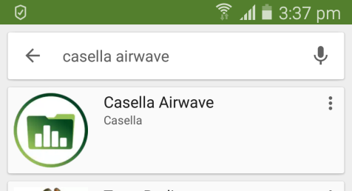
To install the Airwave software:
- On your mobile device go to the Play Store and search for Casella Airwave.
- Click the Casella Airwave selection to install the software.

Bluetooth Connection and Security

With Bluetooth® enabled, Airwave compatible products will always broadcast their basic status and dashboard data and will be visible on any number of local mobile devices running the Airwave Software.
However, Airwave compatible products, such as the VAPex, will only accept connection and control requests from a single known or paired mobile device. This prevents an unknown mobile device making a connection and then interrupting an active measurement run.
To pair a mobile device with your pump:
- Ensure the pump is in Stop mode and that Bluetooth is switched on.
- On your mobile device, open the Airwave software.
The identity of your mobile device is saved within the pump, and only this mobile device can connect to the instrument during an active run.

Dashboard View
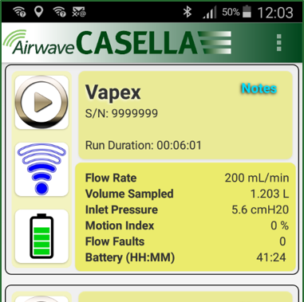
When the Airwave Software is first opened it automatically scans for any Airwave compatible products within range (up to 25m in a direct line with no solid obstructions in the path).
The dashboard provides an instantaneous view of the measured data and status of all Airwave compatible devices in range. Each device updates and broadcasts its dashboard data every 3 seconds approximately.
To save power, the Airwave Software stops scanning when all instruments within range have been detected.
To rescan for new devices, in the top-right corner of the software, touch SCAN.
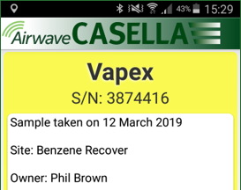
If you touch Notes in the top right corner the screen on the right is displayed. On this screen you can type any relevant notes. When you use the Send Results via eMail option (described on page 26) any notes are also added to the results email.

Control Panel
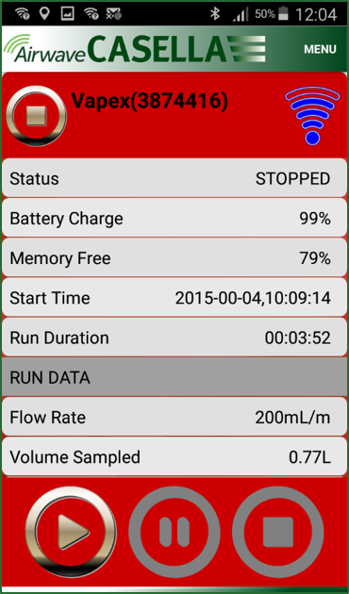
On the dashboard, touch the device you want to control.
A comprehensive set of measurement results similar to those shown on the right will be displayed. You may need to scroll up and down to view all the available data.
On the control panel you can, start, stop or pause a sampling run.
To start, stop or pause a run:
- At the bottom of the screen, touch the appropriate icon for 3 seconds, during which time a countdown is displayed as shown below.
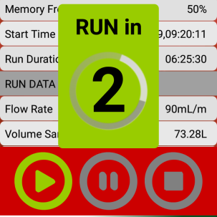
Release at any time during the countdown to abort the operation.

Menu Options
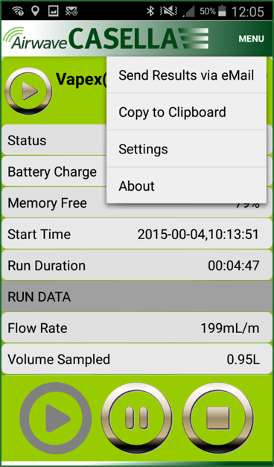
At the top of the control panel screen, touch MENU to display the options you can see in the screenshot on the right. Each option is described below.

Send Results via eMail
Use this option to email the sampling run results to an email address. When you select the option, the following form is displayed that allows you to add some additional information to the email.
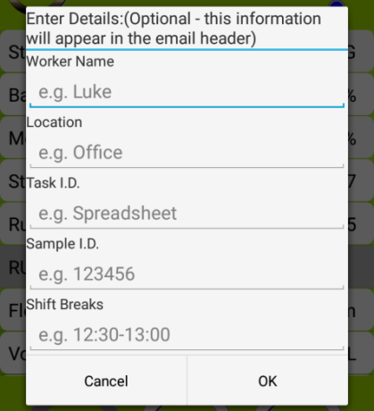
You can alter the field names (see Settings).

Copy to Clipboard
Use this option to copy and paste the sampling run results into any mobile software with text editing capabilities.

Settings
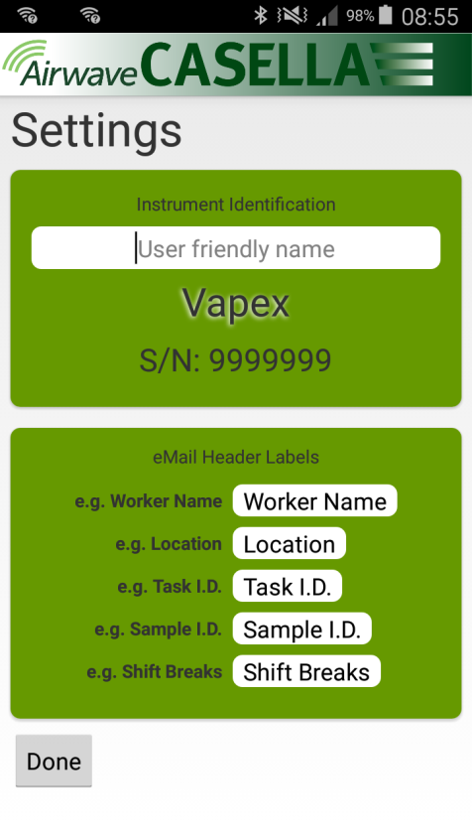
Use this option to:
- Give the instrument a familiar name.
- Change the field names on the Send Results via eMail form.

About
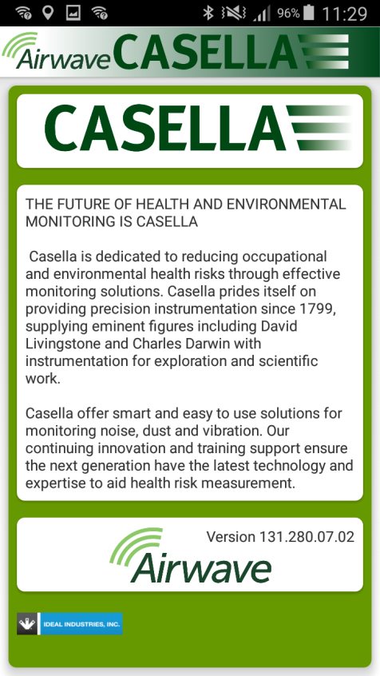
Use this option to see the version number of the Airwave software.

Computer Download Utility
The VAPex data download utility application allows you to download all the data from the pump, which is automatically loaded into an Excel spreadsheet file. You can then use this data directly in any reports you need to prepare. The VAPex Pro includes data graphing capabilities in the Excel spreadsheet file.

Install the Utility
To install the application:
- In your browser, enter the following URL:
- https://www.casellasolutions.com/uk/en/support/product-support.html
- Click VAPex
- Click Software and Utilities.
- Click VAPex Data Download Utility to download the utility.
- Install the utility EXE file or save it for later installation.

Download Data from the Pump
To download data from the pump:
- Connect the charging station to your computer with the supplied USB cable and ensure the charging station power supply is connected and switched on.
- Open the VAPex Download Utility.  - Turn on the pump and place it on the charger. If you have a 5-way charger, place the pump in the pocket nearest to the USB connector.  - On the menu bar, click 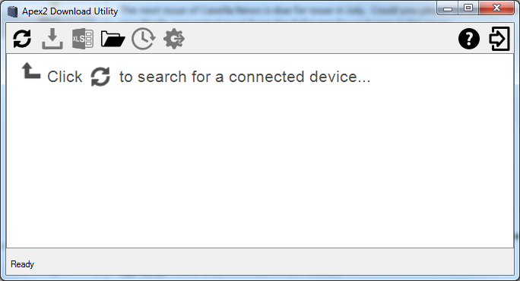 to scan for connected devices. | 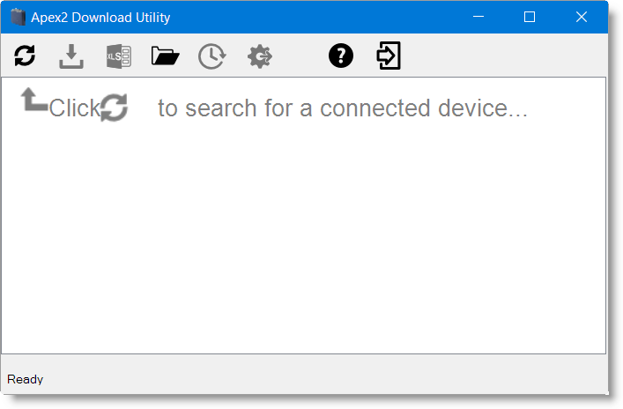
Your pump should be listed as shown in the example on the right.  - On the menu bar, click 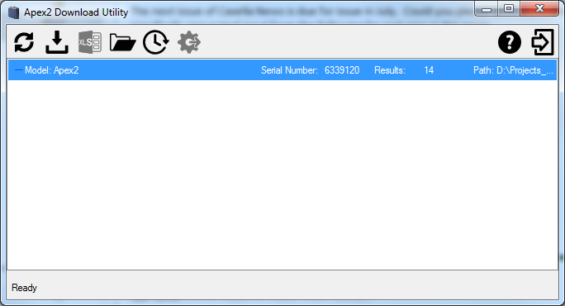 to download the data. You will be prompted to navigate to the folder in which you want to store your Excel file.  - Navigate to a folder and click OK.  Note: The folder you select is used by the utility in subsequent downloads unless you select a different folder. | 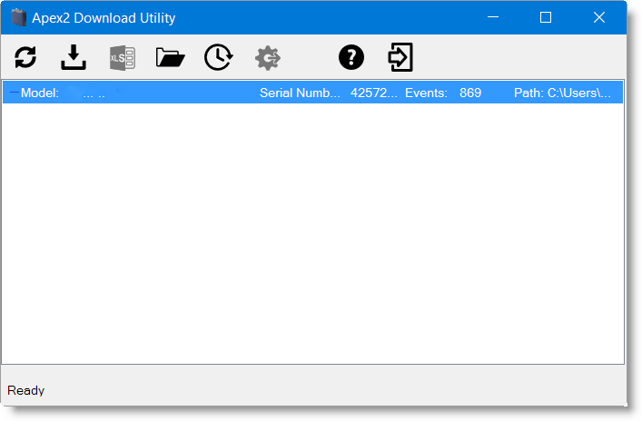
The data is downloaded and when finished the Download complete message is displayed.  - Click OK to remove the message. | 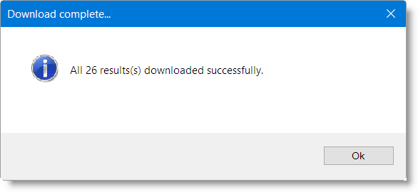
The downloaded data is loaded into an Excel file.  A link to the file is displayed in the utility as you can see in the example shown.  You can double-click the link to open the Excel file.  You can also click to open your selected folder containing any downloaded Excel files. | 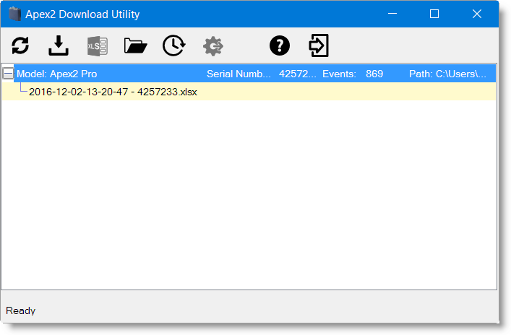

Technical Specifications
Flow Performance
Flow Range ml/min | 20 to 500
Flow Control | < ± 5% (50-500 ml/min)  < ± 5% or ±3 ml (<50 ml/min)
Back Pressure Capability | see Battery Performance table on page 31
Fault Detector | Detects blockages with a selectable number of automatic restarts up to 15 times

Operating
Display | Colour OLED
Controls | 4 buttons
Status Indicators | Red/Green/Blue LEDs (see LED Indicators on page 23)
Dimensions | 86 x 82 x 46 mm (3.38 x 3.23 x 1.81 inches)
Weight | 261.4g (9.2 oz)

Environmental
Temperature | Operation, 0 to 45°C or 41 to 113°F  (for IS Certification –20 to 45°C or –2 to 113°F)
Temperature | Storage, –10 to 50°C or 14 to 122°F
Humidity | 30 to 95% RH (non-condensing)
Barometric Pressure | Auto-correcting
Ingress Protection | IP65

Electrical
Battery Type | Li Ion
Battery Level Indicator | Yes
Battery Life | >34 hours @ 200 ml/min (20 cm H₂O)
Chargers | Single or 5-way
Charge Time | Typically <6 hours
Compliance | EN1232 Compliant
Compliance | ISO 13137 Compliant

Battery Performance Table

Flow rate  (ml/min) | Battery Life (hrs) at below four back pressures (cm H₂O)
Flow rate  (ml/min) | 10 | 20 | 40 | 70
50 | 41.7 | 40.3 | 39.1 | 36.8
100 | 38.5 | 37.9 | 36.8 | 32.9
200 | 34.2 | 33.3 | 31.6 | 29.4
300 | 31.3 | 29.8 | 28.1 | 25.0
400 | 27.5 | 26.6 | 24.0 | 21.9
500 | 24.0 | 23.1 | 21.4 | 18.8

The following chart provides battery life figures for a wide range of back pressures.

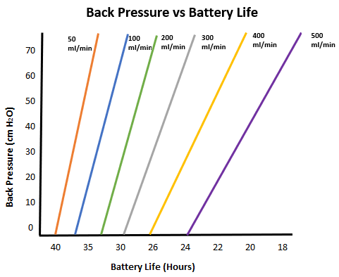

Declarations
WIRELESS BLUETOOTH 4.0 CONNECTIVITY
Only VAPex Pro models support wireless connection via Bluetooth® 4.0 (Low energy or Smart). This connectivity is compatible with mobile and PC devices that support Bluetooth® 4.0 only.
TX power: 0 dBm to -23 dBm
Receiver sensitivity: -93 dBm
Range: Typically >25m line-of-sight and depending on local RF conditions.
The instrument contains a Bluetooth® Low energy wireless transmission module, BLE113 from Bluegiga technologies. The Bluetooth® Qualified Design IDs for this module are:
Bluetooth Controller QDID: B021015, Bluetooth Smart Software: QDID B018942
Copies of the modules regional approvals certificates may be obtained from Casella or Bluegiga.


This product contains an FCC and Industry Canada certified Bluetooth® Low energy wireless transmission module:
FCC IDENTIFIER: QOQBLE113
Industry Canada IC:5123A-BGTBLE113(Single)
Producer: BlueGiga Technologies Inc.
Model: BLE113 Bluetooth smart module
Modular Type: Single Modular
FCC CONFORMITY STATEMENT
This device complies with Part 15 of the FCC Rules. Operation is subject to the following two conditions:
(1) This device may not cause harmful interference
(2) This device must accept any interference received, including interference that may cause undesired operation

RADIATION EXPOSURE STATEMENT
The product complies with the FCC portable RF exposure limit set forth for an uncontrolled environment and is safe for intended operation as described in this manual.


CE DECLARATION OF CONFORMITY
Casella declares that this product is in compliance with the essential requirements and other relevant provisions of applicable EC directives. A copy of the EU Declaration of Conformity for this product may be obtained by clicking on the product compliance documentation link at www.casellasolutions.com.

WEEE - INFORMATION FOR EU MEMBER STATES ONLY
The use of the WEEE symbol indicates that this product may not be treated as household waste. By ensuring this product is disposed of correctly, you will help prevent potential negative consequences for the environment and human health, which could otherwise be caused by inappropriate waste handling of this product. For more detailed information about recycling of this product, please contact your local waste disposal service or contact the agent where you purchased the product.

INTRINSIC SAFETY CERTIFICATION
Intrinsically Safe ATEX and IECEx variants of the VAPex pump are marked:
Ex ia IIC T4 Ga
(Ta = -20^{O}C to +45^{O}C)

Frequently Asked Questions

What is the difference between the Standard and Pro models?
We recognise that different users have different requirements and that is why we have created the two models listed in the table below. If you just want a basic version of the pump, i.e. without Bluetooth® and programming BUT with the same GREAT PERFORMANCE the VAPex standard is the pump you need but if you would like greater functionality including the ability to remotely view the worker, please review the options.

 | VAPex | VAPex Pro
Intrinsically safe | ✔ | ✔
Flow range ml/min | 20-500 | 20-500
Back pressure capability | See table on page 31
Battery type | Li Ion | Li Ion
Battery life | >34 hrs | >34 hrs1
Display type | Colour | Colour
Motion sensor | ✔ | ✔
Bag outlet | ✔ | ✔
User lock | ✔ | ✔
Pump status indicator | ✔ | ✔
Fuel gauge | Batt. level icon | Fuel gauge
Bluetooth® |  | ✔
Airwave mobile app |  | ✔
Computer download |  | ✔
Constant pressure mode | ✔ | ✔
Run duration timer |  | ✔
Fully programmable timers |  | ✔
Time weighted average mode |  | ✔
Graph time history data (via software) |  | ✔

I would like to upgrade models – is this possible?
If you own the Standard VAPex, this is possible.

What program options are there for the VAPex?
The VAPex Pro has these additional program options:
- Run duration timer – you can set the unit to run for a programmed duration, for example 8 hours only.
- Timer facility – you can set a start and a finish time for a particular day.
- TWA (time weighted average) mode – you can set the pump to operate for a fixed percentage of a specified sample time. The pump calculates the required on/off cycle automatically to spread the total exposure time over the entire sample time.

Is there an intrinsically safe version?
All VAPex pumps are intrinsically safe. Intrinsic safety details are printed on the label affixed to the back of the unit.

What is the recommended service interval for the VAPex?
Casella recommends annual factory maintenance and recalibration for accurate and reliable operation. The VAPex pump logs usage and a reminder will appear after 3000 hours if this comes sooner than 1 year. This is based on use at 200ml/min at 20 cm H₂O backpressure. For further information about servicing, please contact salessupport@casellasolutions.com.

How do I know what sorbent tubes and accessories I need for my application?
Sorbent tubes and accessories do depend very much on your application. Please visit airsamplingsolutions.com or contact info@casellasolutions.com for further information. The website has a hazard search, which returns recommended methods and the equipment required.

Why include a motion sensor?
Workers are occasionally resistant to being monitored and feel that wearing the pump hampers their work. There have been examples of workers taking the equipment off and leaving it running in a cupboard and picking it up again at the end of a shift to hand it in to the Occupational Hygienist. The motion sensor tracks the amount of movement and gives an index to the Occupational Hygienist who can then tell if the sample is a valid one. If the pump has not been moving all day, it’s quite likely it’s been taken off.

Is wearer acceptance a problem then?
It can be – workers’ may not always see the benefit of being monitored and only see that wearing a pump will be an unnecessary encumbrance rather than the long-term goal of protecting their health. To try and combat this, the VAPex has been designed to be less obtrusive to the wearer. It’s a smaller, slimmer, lighter design, which makes moving around easier: sitting, standing and climbing. The sturdy clip can be fitted to a variety of belts and harnesses. The innovative design of VAPex safeguards the screen and nozzle against knocks and drops.

What is the battery life and charge time and what’s the benefit?
The VAPex incorporates Li Ion battery for a greater battery life. You can be confident that you can get to the end of the shift without running out of charge. Battery life does depend on the application, and factors such as the flow rate and the back pressure must be taken into account. It is difficult to give a definitive answer as to ‘how long will the charge last’ because it does depend on the individual sample. We can only give guidance.

What is the flow control and why is that so important?
During the sample run a number of factors can slow the pump, for example a blockage in the tube or reduced battery voltage, resulting in a reduced flow rate. If this happens the air volume measurement becomes inaccurate, affecting the accuracy of your results. To counter this potential issue, the VAPex monitors and maintains flow accuracy so you can have confidence in your results.
The VAPex conforms to ISO13137:2013, which states that flow control is ±5% for ambient temperatures between +5 to 40°C and pressures of 850 to 1,255 mBar. This is the international standard specifying performance requirements for personal sampling pumps.

What is back pressure?
This is the resistance to flow caused by the sorbent tube media as opposed to free flow of air through the pump (like having a sock over your vacuum cleaner nozzle, the pump has to work a bit harder!). Back pressure is measured in inches or cm of water. The smaller the pore size of your sorbent tube, the greater the back pressure and the harder the pump has to work. As well as being a drain on the battery the pump needs to be powerful enough to overcome the resistance. Another factor is the flow rate and it is the combination of flow rate and sorbent tube media that determines the back pressure.
Having a pump that is capable of dealing with a wide variety of flow rates and sorbent tube media is really important and the VAPex has class beating back pressure capability. Please refer to the table below for typical back pressures exerted by particular sorbent tube media.

Servicing, Maintenance and Support

Servicing
The VAPex pump contains no user serviceable parts and if a fault is suspected, return the pump to Casella or a Casella approved service centre.
The warranty DOES NOT extend to cleaning or general servicing of the instrument.
Casella’s in-house service department offers a comprehensive range of repair and calibration services designed to maintain a fast and efficient back-up for all our products. The Service Department is operated in accordance with our BSI registration for products manufactured by us. We will however, undertake the repair of other manufacturer’s equipment.
For further information please contact our service department at our UK headquarters (salessupport@casellasolutions.com) or contact an approved servicing distributor. We will be happy to provide quotations for individual repairs or provide annual maintenance under contract.
Intrinsically Safe products must only be repaired by Casella or an authorised body.

Maintenance
The VAPex Personal Sampling Pump is designed to provide long and reliable service. Routine maintenance should be minimal.
- Avoid leaving the battery pack in a discharged condition for extended periods.
- Do not operate without an inlet filter. Ingested dirt and dust particles may cause internal damage, malfunction or erratic flow.
- Replace the inlet filter every 3 months.
Note: The pump running time and the operating environment can reduce this time considerably.
- Keep the instrument body clean.

Replacing the inlet filter
To replace the inlet filter:
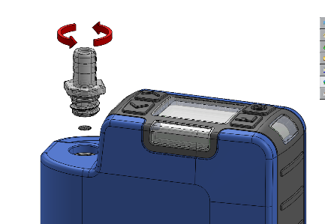
- Unscrew and remove the inlet nozzle using a spanner.
- Discard the filter element.
- Fit a new filter element and ensure it is centrally located to achieve a good seal.
- Refit and tighten the inlet nozzle.

Support
For support, please got to casellasolutions.com or email us at salessupport@casellasolutions.com.

Part numbers and accessories
VAPex models
VAPEX | VAPex IS Standard pump
VAPEXPRO | VAPex IS Pro pump

All pumps include a 1 m tube, Field Guide and Certificate of Conformity.

VAPex accessories
214020B/KIT | Single docking station for VAPex pump inc. PSU and USB cable
214024C/KIT | 5-way docking station for VAPex pump inc. PSU and USB cable

VAPex kits
VAPEX/KIT | 5-way VAPex IS standard kit
VAPEXPRO/KIT | 5-way VAPex IS Pro kit

At optimum working conditions of 200 ml/min and a 20 cm H₂O back pressure.
Provides an estimated time remaining based on the current mode. This is much longer when the pump is stopped.

